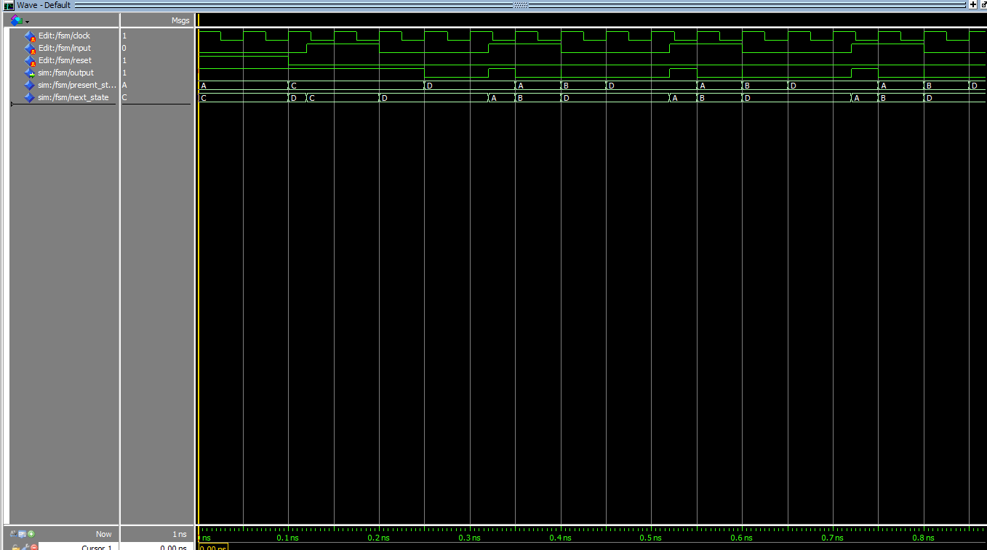

library ieee;

use ieee.std_logic_1164.all;

entity fsm is

port(

reset, input, clock: in std_logic;

output: out std_logic

);

end fsm;

architecture fsm_logic of fsm is

type state_available is (A,B,C,D);

signal present_state, next_state : state_available;

begin

process(clock, reset) begin

if(reset='1') then

present_state <= A;

elsif(rising_edge(clock)) then

present_state <= next_state;

end if;

end process;

process(present_state, input) begin

case present_state is

when A =>

if(input='0') then

output <= '1';

next_state <= C;

else

output <= '0';

next_state <= B;

end if;

when B =>

if(input='0') then

output <= '0';

next_state <= D;

else

output <= '1';

next_state <= B;

end if;

when C =>

if(input='0') then

output <= '1';

next_state <= D;

else

output <= '1';

next_state <= C;

end if;

when D =>

if(input='0') then

output <= '0';

next_state <= D;

else

output <= '1';

next_state <= A;

end if;

end case;

end process;

end architecture;